C programming lab file

**Manav Rachna International Institute of Research and Studies**

**School of Computer Applications**

**Department of Computer Applications**

Student Name- Sneha Sidhu

Roll No- 24/SCA/BCA(AI&ML)/065

Programme- BCA(AI/ML)

Semester- 1

Section- IB

Batch- 2024-27

Faculty Name- Miss Iram Fatima

Question-1

Write a Program to perform arithmetic operations (Addition, Subtraction, Multiplication, Division) on two numbers.

Input:

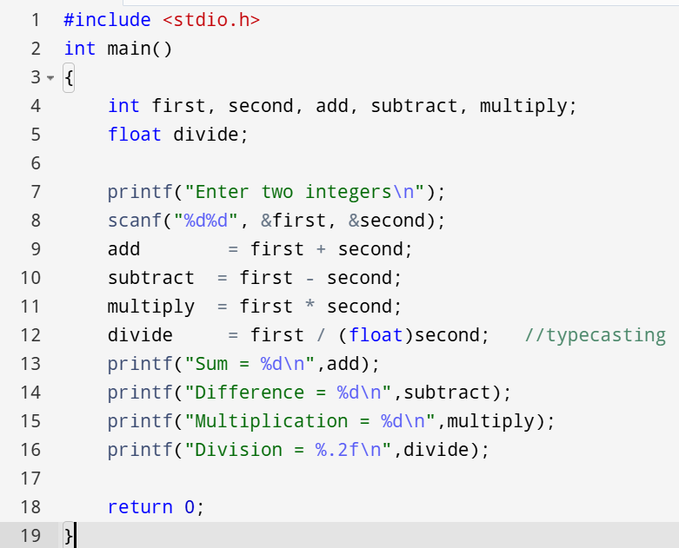

Output:

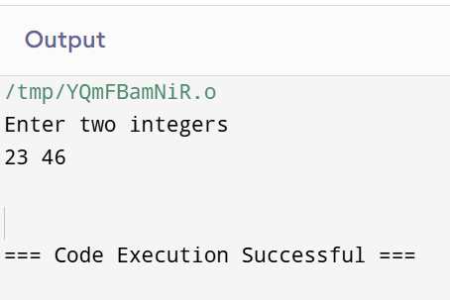

Question-2

Write a Program to calculate gross salary of an employee [using formula:gross_sal = basic_sal+hra+da].

Input:

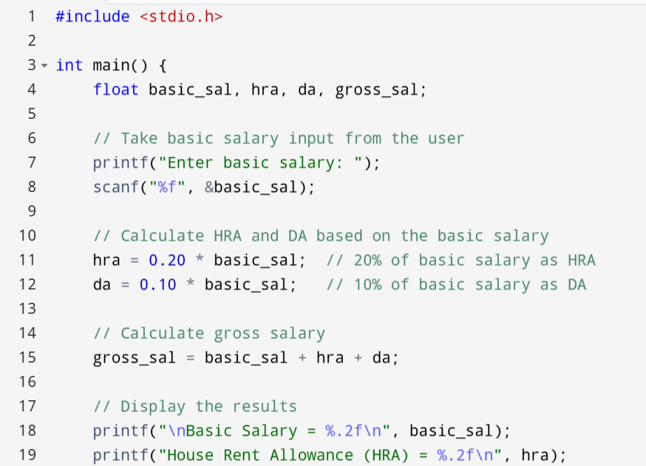 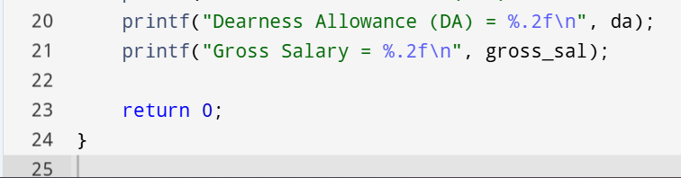

Output:

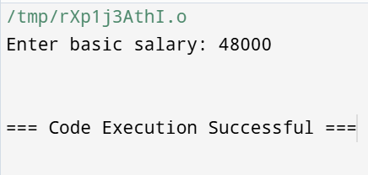

Question-3

Write a program to find sum and reverse of three-digit number

Input:

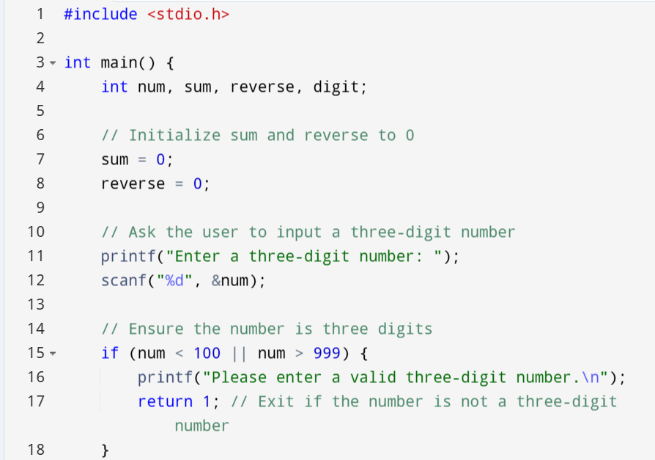

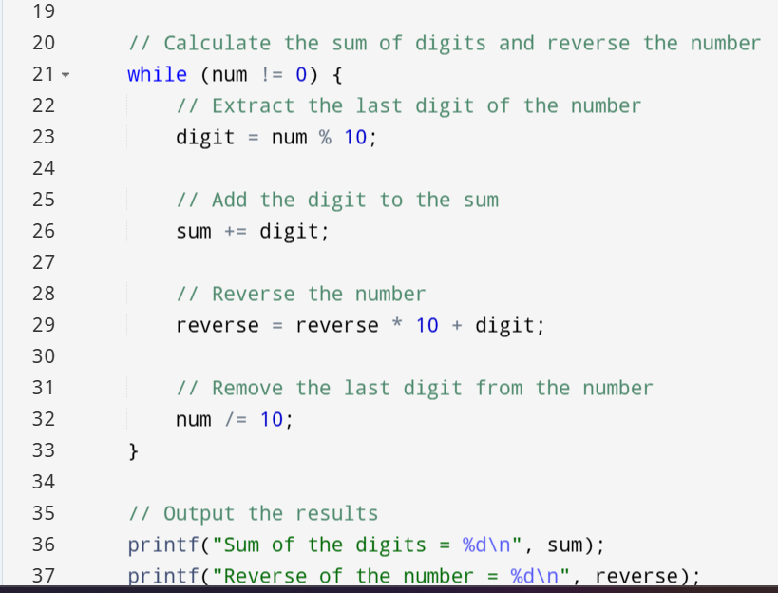

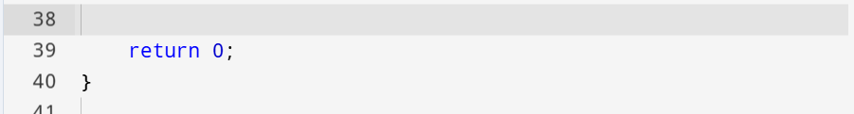

Output:

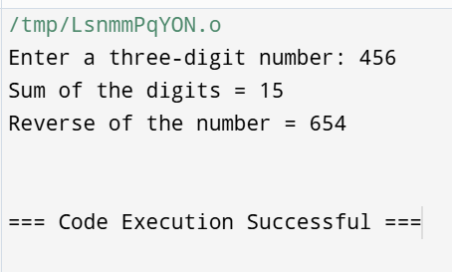

Question-4

Write a Program to swap two numbers without using third variable

Input:

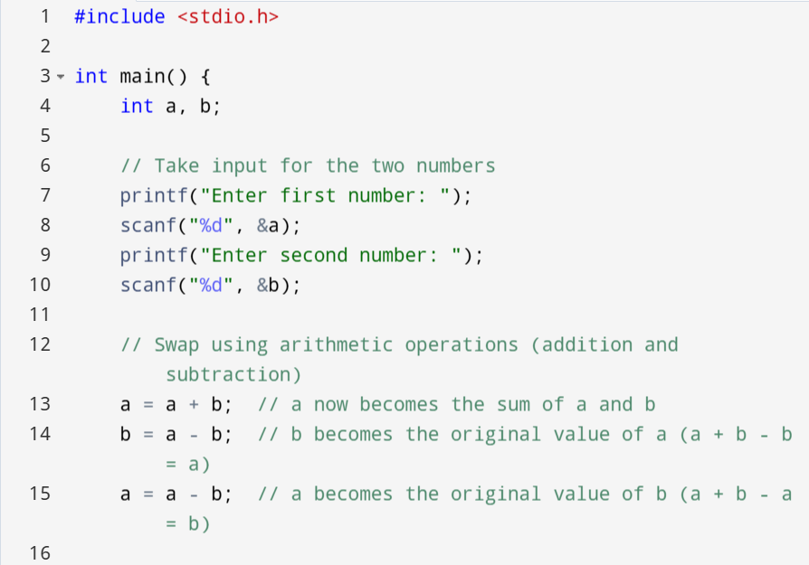

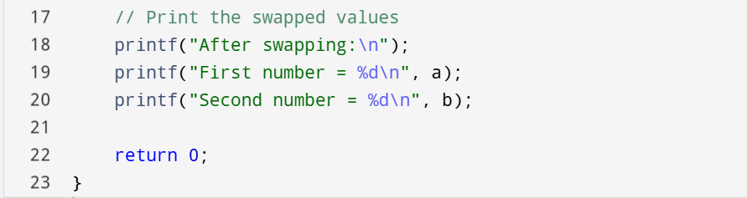

Output:

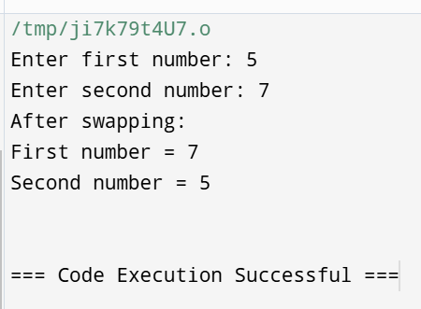

Question-5

Write a Program to print a table of any number

Input:

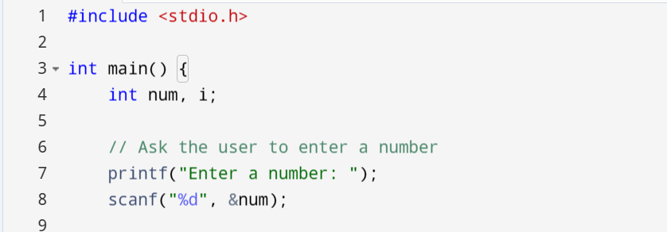

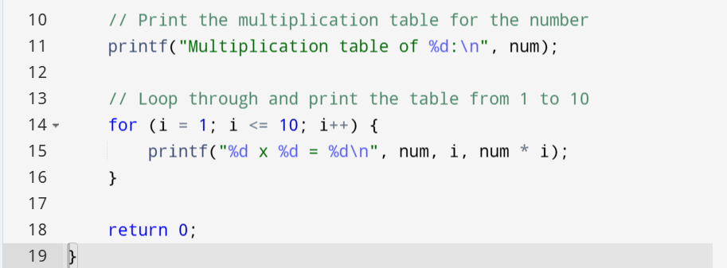

Output:

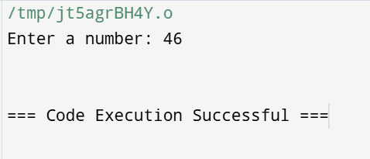

Question-6

Write a Program to find greatest in 3 numbers.

Input:

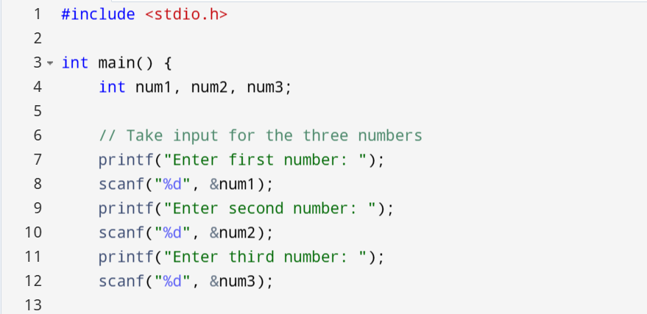

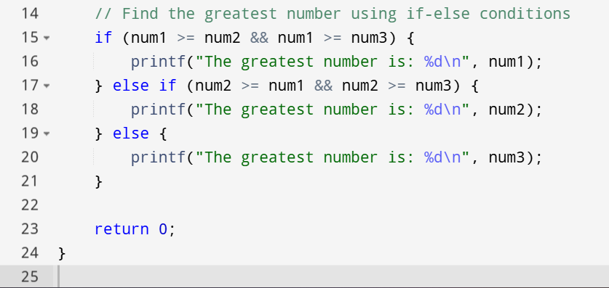

Output:

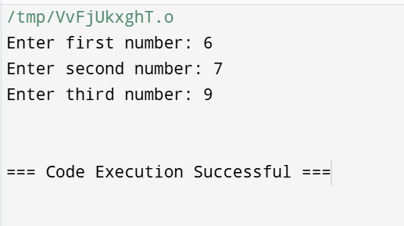

Question-7

Write a Program to find that entered year is leap year or not.

Input:

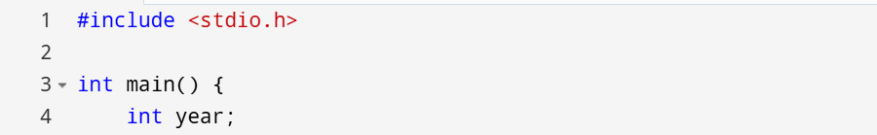

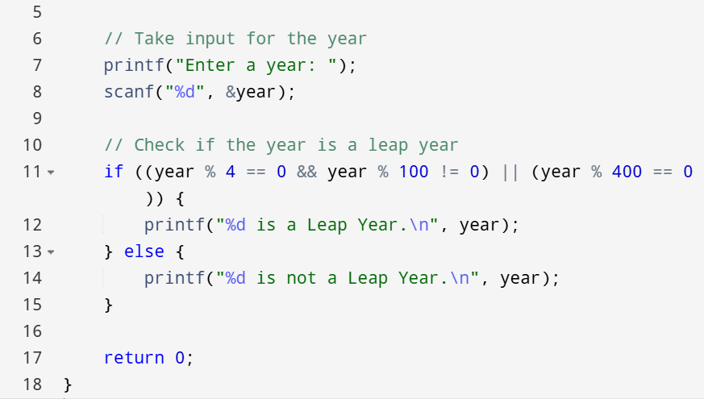

Output:

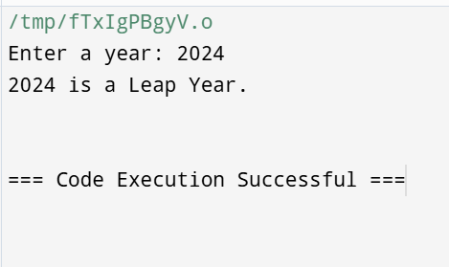

Question-8

Write a Program to find whether given no is even or odd.

Input:

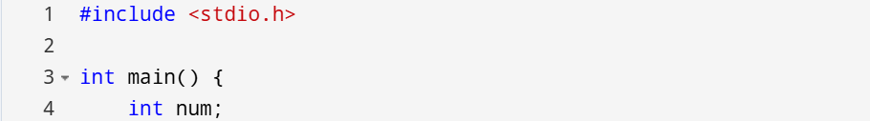

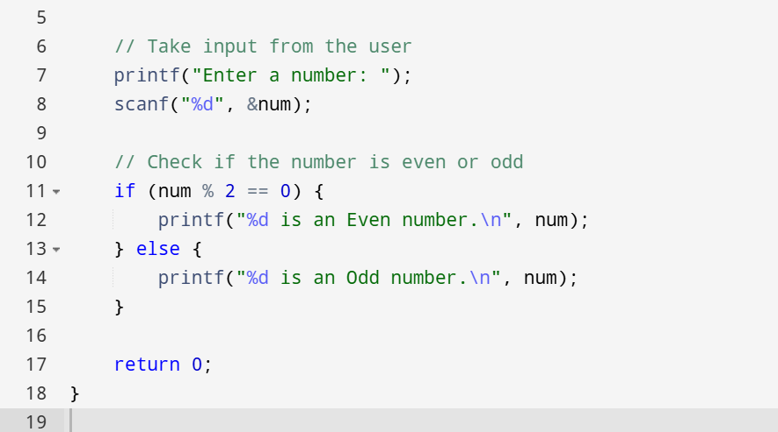

Output:

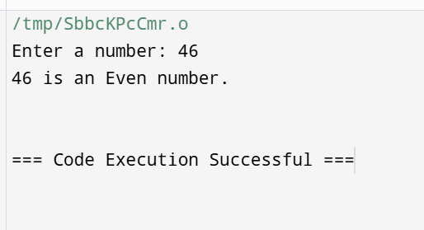

Question-9

Write a program to find the roots of a Quadratic Equation.

Input:

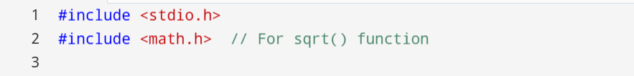

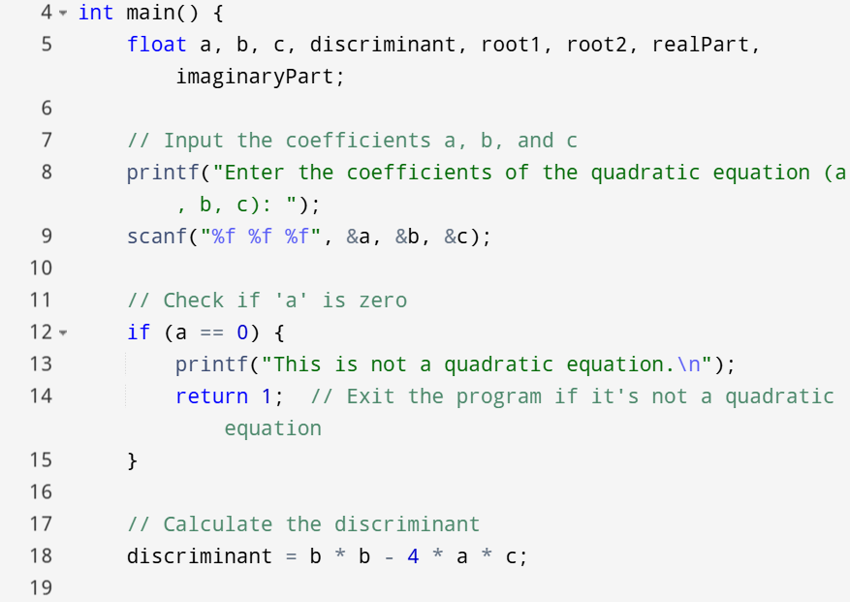

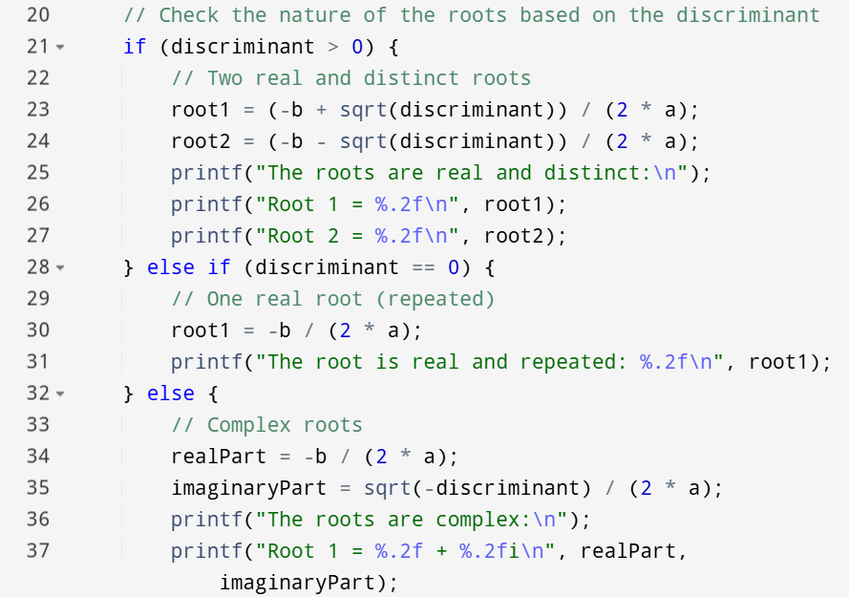

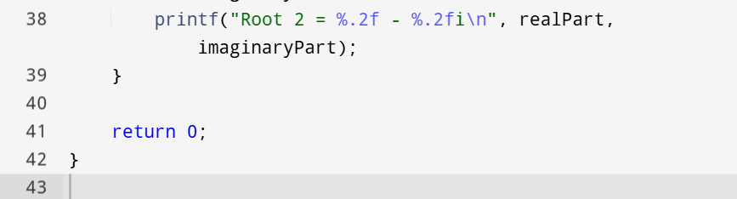

Output:

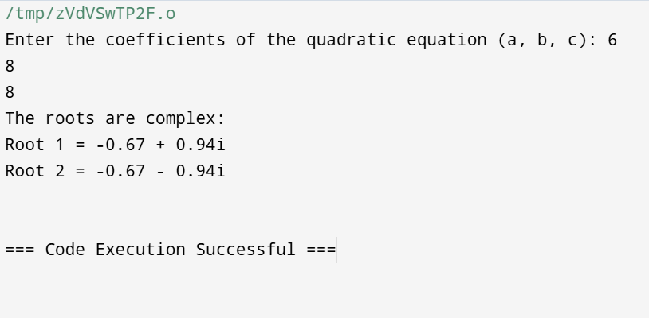

Question-10

Write a Program to use switch statement. Display Monday to Sunday.

Input:

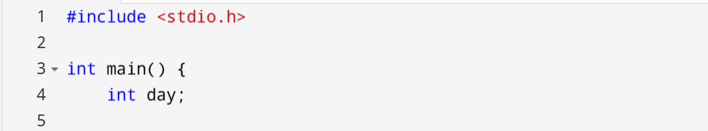

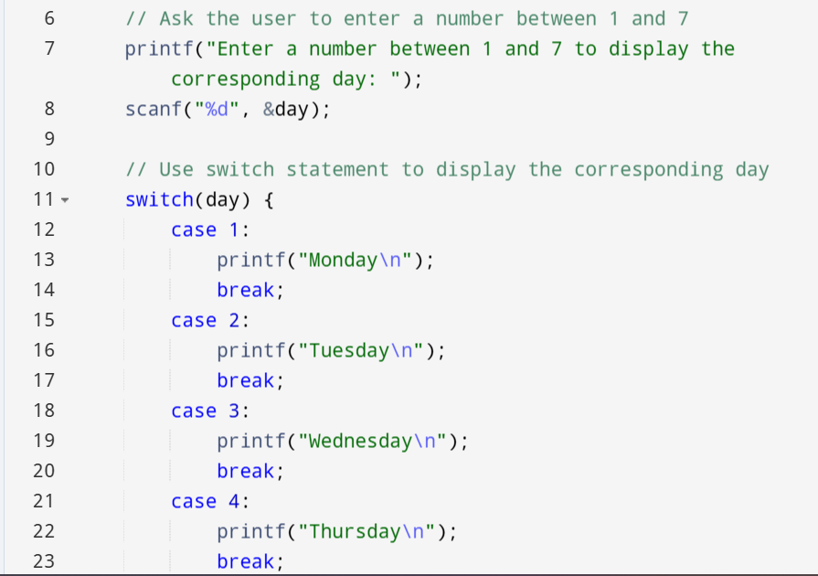 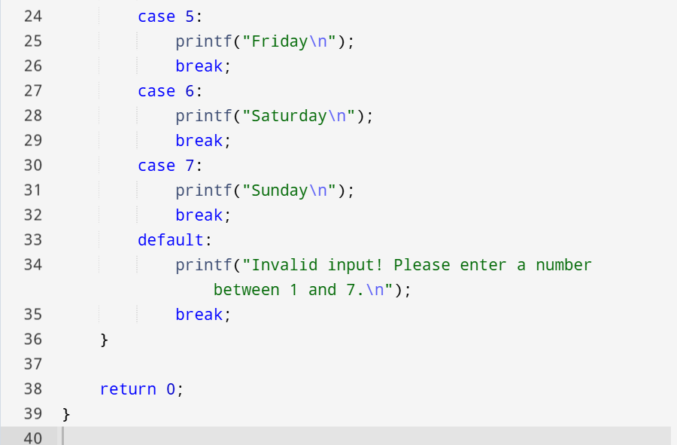

Output:

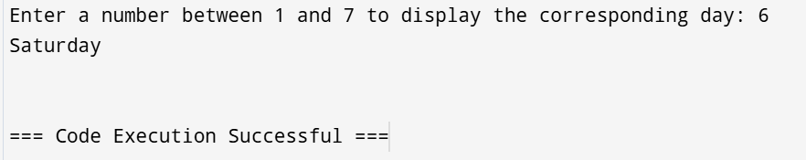

Question-11

Write a Program to calculate power of a number using #DEFINE

Input:

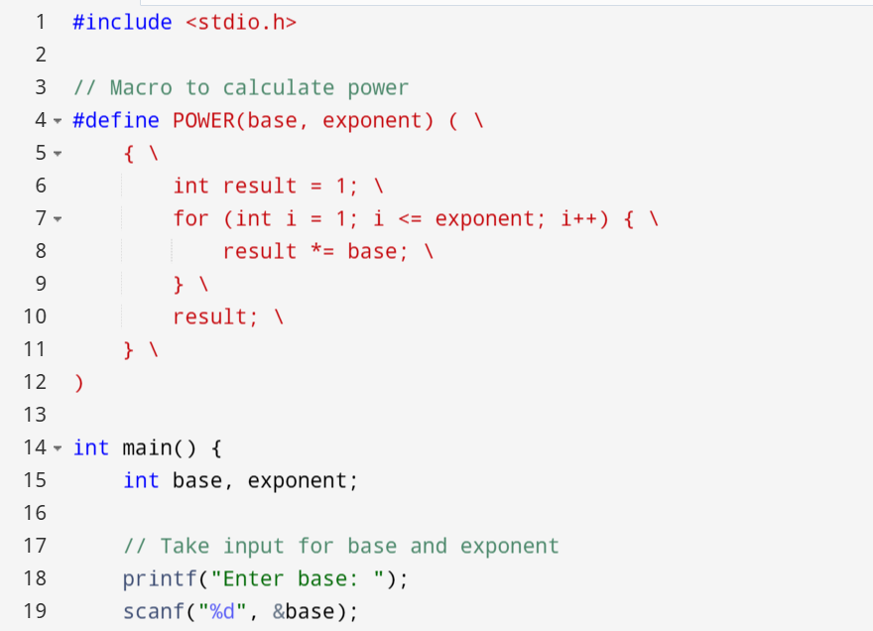 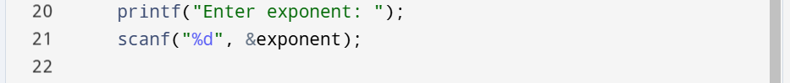

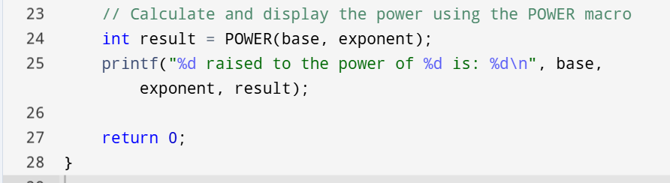

Output:

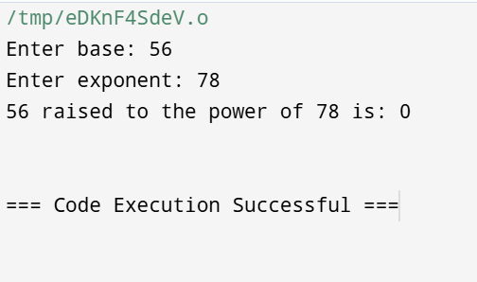

Question-12

Write a Program to display first 10 natural no & their sum.

Input:

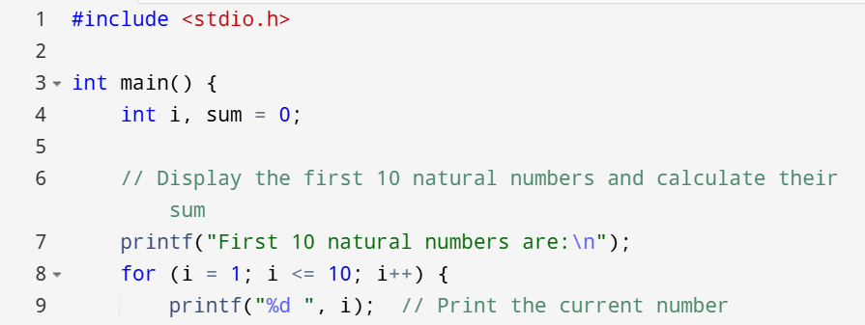

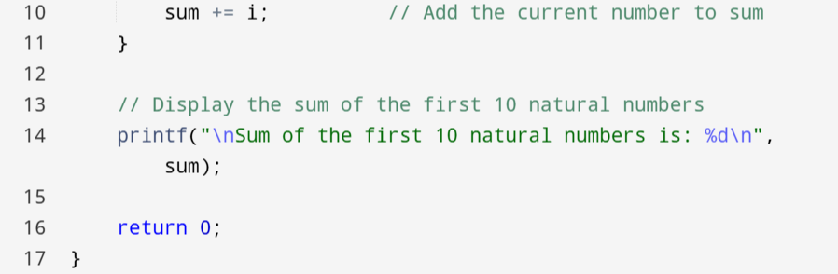

Output:

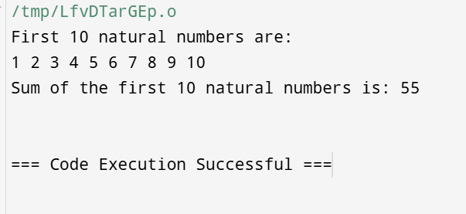

Question-13

Write a program to find the factorial of n number.

Input:

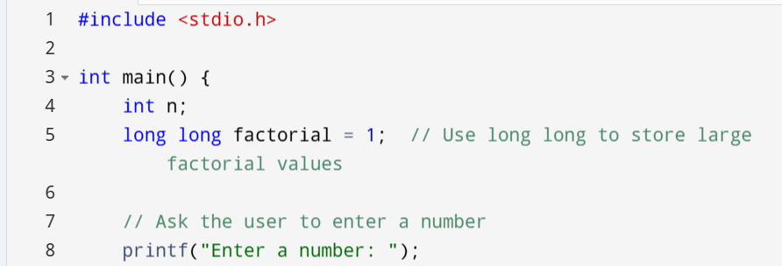

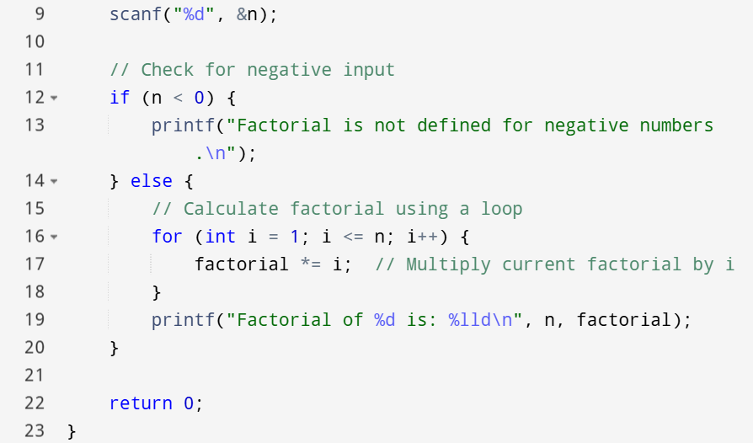

Output:

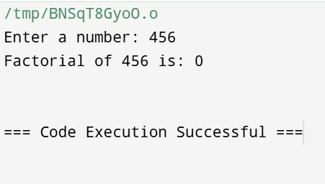

Question-14

Write a program to generate the Fibonacci series up to n terms.

Input:

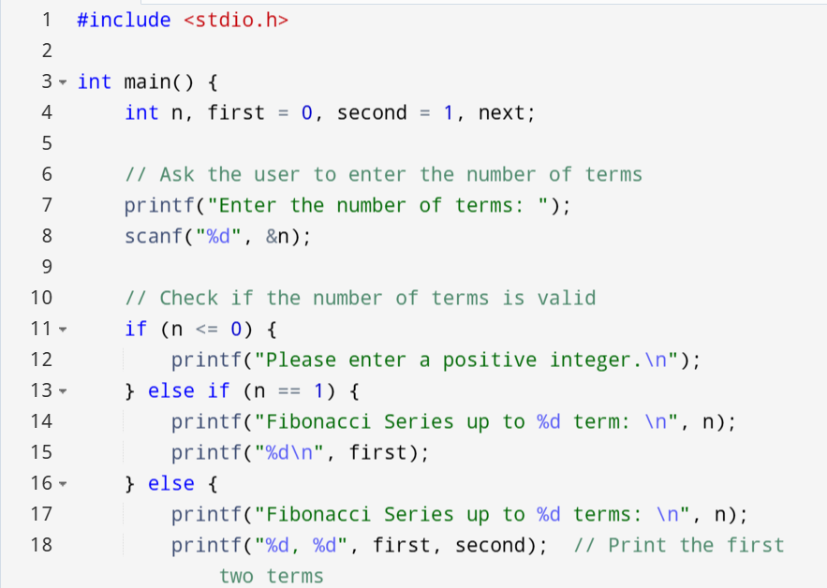 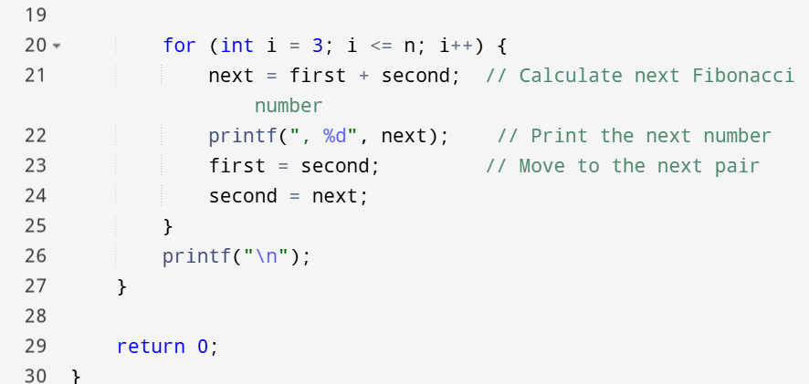

Output:

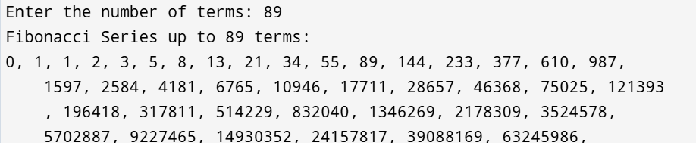

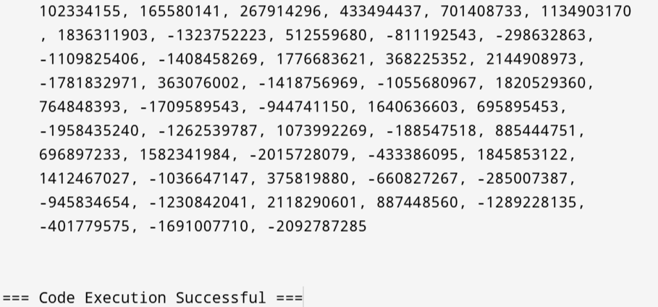

Question-15

Write a Program to print stars Sequence.

*

**

***

****

*****

Input:

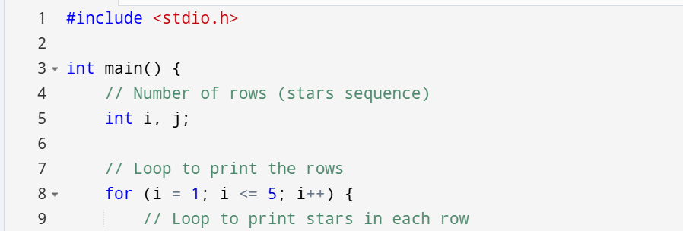

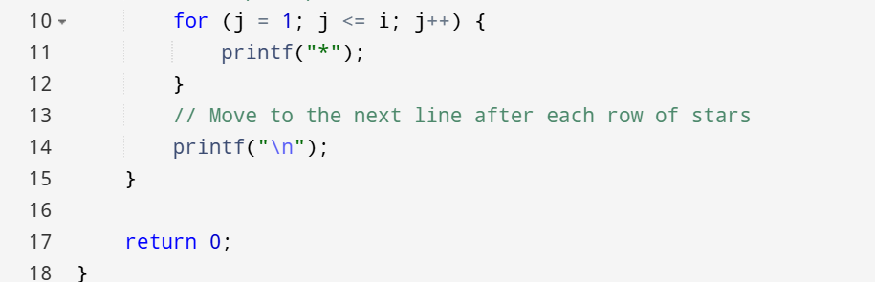

Output:

